**FIRE DETECTION SYSTEM AND MESSAGING USING ARDUINO**

Harshitha Prabakaran (Roll No: 19Z320)

Lavanya Ra (Roll No: 19Z328)

Sushmitha S(Roll No: 19Z352)

Swetha GN (Roll No: 19Z354)

Dissertation submitted in partial fulfillment of the requirements for the degree of

**BACHELOR OF ENGINEERING**

**Branch: COMPUTER SCIENCE AND ENGINEERING**

of PSG College of Technology



May 2022

DEPARTMENT OF COMPUTER SCIENCE & ENGINEERING

PSG COLLEGE OF TECHNOLOGY

(Autonomous Institution)

COIMBATORE – 641 00

**CONTENTS**

Introduction

Problem Statement

Components Required

Schematic Diagram

Code

Challenges Faced

Contribution of Team Members

References

Plagiarism report

1. **Introduction**

The Fire Alarm Circuit is a simple circuit that detects fire and sounds the Siren or Buzzer. Fire Alarm Circuits are critical equipment for detecting fires in a timely manner and preventing damage to people and property.

Security systems include fire alarm circuits and smoke sensors, which aid in the detection and prevention of harm. Commercial buildings, such as offices, movie theaters, shopping malls, and other public locations, must have fire alarm systems and smoke sensors installed

.

When smoke, fire, carbon monoxide, or other problems are present, a fire alarm system has a variety of devices working together to detect and alert people using visual and audible equipment. These alarms can be triggered by smoke and heat detectors, or by manual fire alarm activation mechanisms such as manual call points or pull stations. Alarms can be either motorized bells or sounders or horns that can be mounted on the wall. They can also be speaker strobes that sound an alarm and then play a voice evacuation message that advises people not to use the elevators. Depending on the country and manufacturer, fire alarm sounders can be adjusted to different frequencies and tones, such as low, medium, and high.

1. **Problem Statement:**

An automatic fire alarm system monitors environmental changes linked with combustion to identify the unexpected presence of fire. A fire alarm system is either automatically actuated, manually operated, or both in general. When a fire is detected by a flame sensor, automatic fire alarm systems are designed to inform individuals by SMS to escape in the event of a fire.

The goal of this project is to design and develop a fire alarm system that will detect the presence of a fire in a structure.

We have used a GSM module to send SMS to individuals alerting them about the detection of fire so that they can be cautious enough and can take further action. The fire is being detected using a Flame sensor and the alert sound is being given by the buzzer.This project is cost friendly

1. **Components Required**

* Arduino Nano
* SIM800A GSM Module
* Infrared Flame Sensor
* Buzzer
* A 3.7V Battery
* Few jumpers wires
* Breadboard

1. **Schematic Diagram**

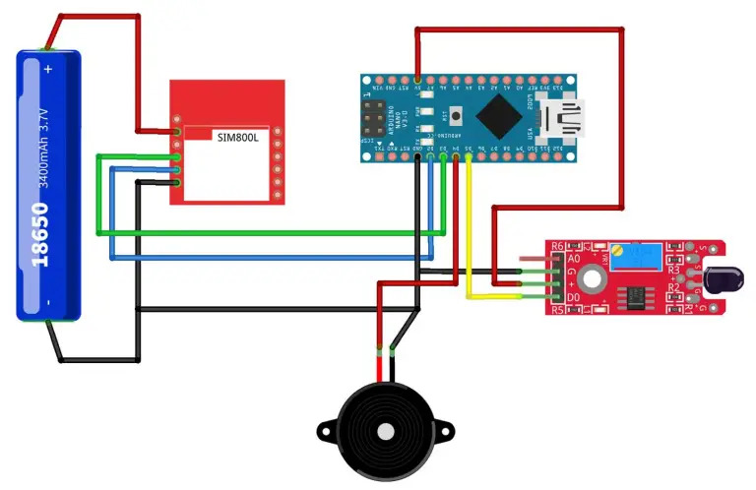

**4. Code**

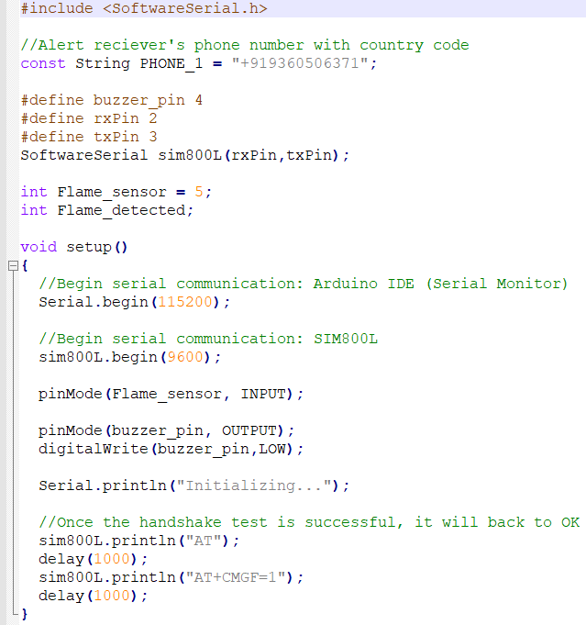

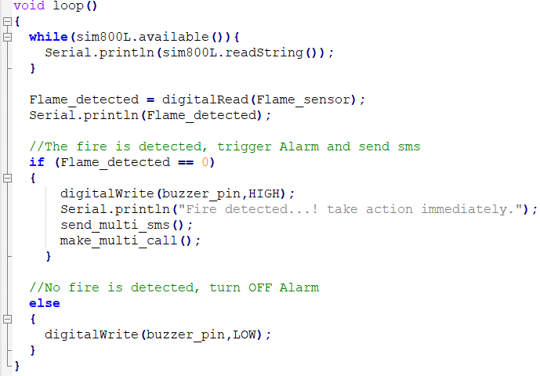

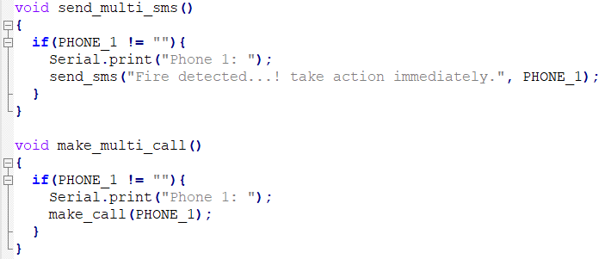

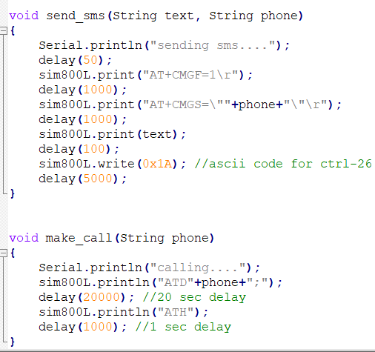

1. **Challenges Faced**

* Our project involves creating a connection so that user would be alerted when the embedded system detects fire. There were many available options with which one could create the connectivity like WiFi, Ethernet, Bluetooth, GSM, etc. We decided to resolve this issue by selecting the component that was easily to implement and widely available.
* The SIM800L GSM Module was said to be compatible only with 2G or 3G SIM cards, which is something that is not easily found when 4G is widely used in the current scenario. On further research we found that 4G SIMSs have the capability to default to 2G/3G network when required.
* There were some components that were faulty, resulting in the failure of receiving the desired output. It was time consuming and difficult to debug each component to identify the faulty ones and to replace them with an alternate one.

1. **Contributions**

* **Harshitha Prabakaran (Roll No: 19Z320)** -
  + Making call to mobile phone function and triggering multi-call function until user responds
  + Interfacing of GSM module to the Arduino UNO
* **Lavanya Ra (Roll No: 19Z328)** -
  + Sending sms to mobile phone function and triggering multi-sms function until user responds
  + Interfacing of GSM module to Arduino UNO
* **Sushmitha S(Roll No: 19Z352)** -
  + Invoke buzzer on fire detection and make calls to sms module and call module using gsm interface
  + Interfacing of Flame sensor with Arduino UNO
* **Swetha GN (Roll No: 19Z354)** -
  + Setting up of serial communication of the components and flame detection
  + Interfacing of Flame sensor with Arduino UNO

1. **References**
2. <https://theiotprojects.com/gsm-based-fire-alert-system-using-arduino-and-flame-detector-sensor/>
3. **Plagiarism Report**

